NA DVI STRANE

Baranja, Hungary



More than 70,000 Croatians inhabit the southern, central and western parts of Hungary today, where they continue to preserve the heritage, language and culture of their ancestors. Baranja is an area, which straddles the border between northeastern Croatia and southwestern Hungary. Croatians, who have lived there for many generations, inhabit the villages in Hungary near the town of Pécs. Their dances retain their Slavic character, with little or no influence from the surrounding Hungarian culture.

*Željko was researching Croatian culture in the summer of 1992 around the city of Pécs.*

**TRANSLATION:** Dance in both directions

**PRONUNCIATION:** NAH Dvee ST-RAH-Ne

**CD: “BAŠTINA HRVATSKOG SELA”** by Otrov, Band # 2

**FORMATION:** Closed circle, alternating M and W, facing ctr.

**HANDS:** Hands joined in V-position

Women only: R arm bent and across body at waist, L arm resting on neighbors R arm.

**STEPS: FIG I A) Side-close:**

Meas 1-4 2 side-close steps sdwd L /& 1 sdwd R /& 1 sdwd L

5-8 Repeat with opp ftwk moving sdwd R

9-12 Repeat meas. 1 - 4

##### **B)** **Drmeš**

***\*Same ftwk as side-close steps EXCEPT each step is a “drmeš“***

Meas 1: Moving sdwd R - step R to R with knees bent slightly (down) (ct 1); close L beside R and bounce 2 times on both ft (up-up) (cts 2, &) most of wt on L (ct &). (S, Q, Q)

When moving sdwd L use opp ftwk

##### **FIG II**

Meas 1 Step on L and step on R behind L

2 Step L, R, L in place (Q, Q, S)

1. Hop on L, at the same time touch R heel to R (Q); step R

in place (Q); step L next to R (S)

4 Step R, L, R in place (Q, Q, S)

**STYLE:** The drmeš (shaking dance) is done flat-footed with small steps and movements. All ftwk is rather stiff legged and flatfooted.

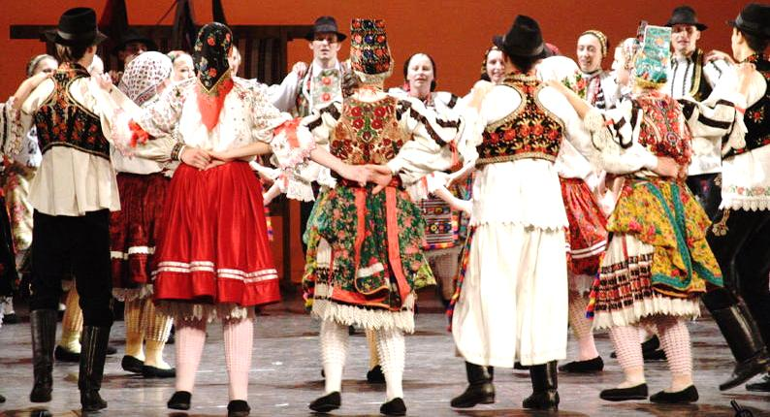---------------------------------------------------------------------------------------------------------------------

**METER:** 2/4 ***PATTERN***

---------------------------------------------------------------------------------------------------------------------

Meas.

**INTRODUCTION:** **4 chords**. Beg with full melody.

*Na dvi strane, Page 2 of 2*

**FIG I A) SIDE - CLOSE:**

1-4 2 side-close steps sdwd L & 1 sdwd R & 1 sdwd L /*1 side-close step per meas.*

* 1. Repeat meas. 1- 4 with opp ftwk and moving in opp direction
  2. Repeat meas. 1- 4

**B) DRMEŠ**

***\*\*\* Same ftwk as side-close steps EXCEPT each step is a “drmeš“***

* 1. Moving sdwd R - step R to R with knees bent slightly (down) (ct 1); close L beside R and bounce 2 times on both ft (up-up) (cts 2, &) most of wt on R (ct &). (S, Q, Q).

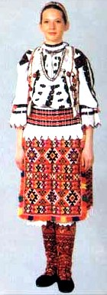 *Repeat one more time – total of 2 drmeš steps sdwd R*

3 Repeat meas. 1 with opp ftwk and moving in opp direction (L)

4 Repeat meas. 1

5-8 2 drmeš steps *sdwd* (L) + one drmeš step *sdwd* (R)

9-12 Repeat meas. 1- 4

##### **FIG II**

1 Step on L and step on R behind L

2 Step L, R, L in place (Q, Q, S)

3 Hop-step-step – starts with L foot and move slightly sdwd R

4 Step R, L, R in place (Q, Q, S)

🟓 ***PATTERN:******Fig. I-II / 4 times + Fig I***



*Ej, diko, pazi, ranije dolazi,*

*Ej, još ranije nego što si prije, 2x*

*Ej, ko što dika taki više nema,*

*Ej, ako ‘š ići odavle do Srijema,*

*Ej, šumo gusta, al’ si puna lada,*

*Ej, ko djevojka prid udaju jada.*

*Ej, šuma mlada puna je borika,*

*Ej, srdimo se ja i moja dika.*

*Ej, dođi, diko, na našu klupćicu,*

*Ej, pa me ljubi kano golubicu.*

*Dance notes by Fusae Senzaki & Željko Jergan*